**Achievement Document**

**To prepare for this assignment, do the following:**

1. Find an achievement.
2. Make sure it is something you can write three paragraphs about.
3. Draft your three paragraphs: what it is, why it is important, and how you achieved it.

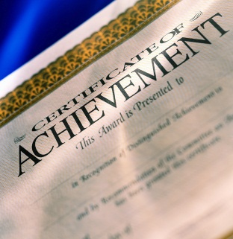 

**Achievement Document Write - Up**

Guidelines

Collect and include **one** of the following documents:

Job certifications, awards, special recognition, honors, grade reports, high school transcript, college acceptance letter, scholarship, or any other achievement you have obtained during your high school years.

Accompanying your document provide a three-paragraph description about it.

Description must include:

* Paragraph #1: Brief description of the achievement
* Paragraph #2: Description of what it took for you to achieve it
* Paragraph #3: Description of what the achievement means to you

In the event that you cannot obtain one of the above documents you can fulfill this requirement by creating your own recognition award and then writing about why you are giving yourself the award. You should write about three reasons for giving yourself the award and you must write three paragraphs. Each paragraph should be about each of your reasons for giving yourself the award.

Only **One** Achievement Document and **One** Write-Up are required for this assignment.